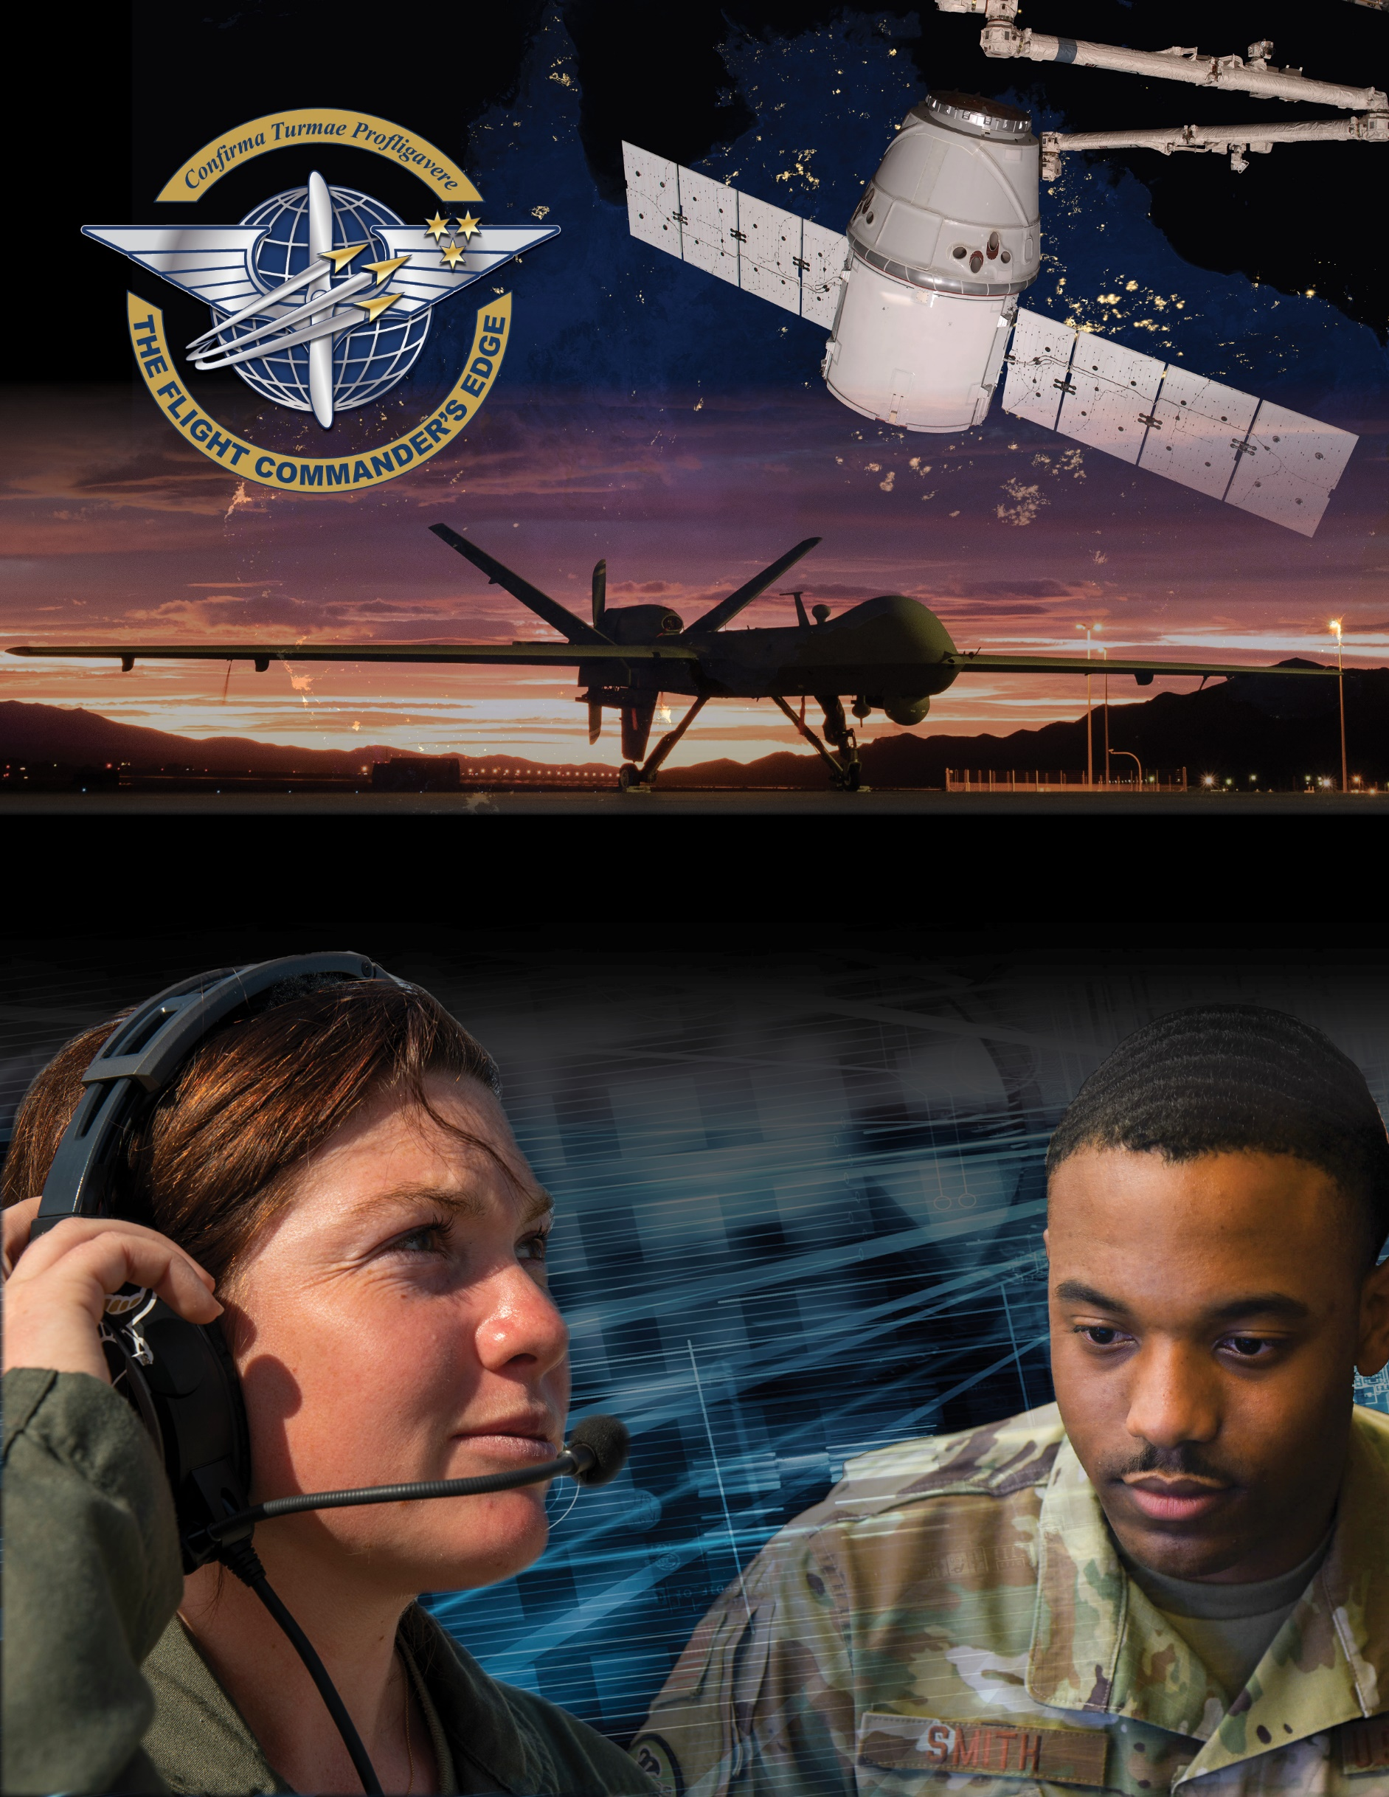

Lesson Plan

Building and Busting Teams
April 2025

Table of Contents
About the Lesson 3
Before the Lesson 4
Presenting the Lesson 5
Appendix: Required Materials and Handouts 10

How to Use this Lesson Plan
This lesson plan is divided into three key sections and an appendix containing supporting material.
The About the Lesson section outlines the lesson and identifies requirements for its effective use. Course Directors should use this section to (a) understand the purpose and context of the lesson, (b) learn about lesson pre-requisites, and (c) guide the selection of facilitators.
The Before the Lesson section provides details on the preparation required for this lesson, including participant prerequisites (if any), recommended facilitator pre-course readings, and guidance on how to prepare the classroom.
The Presenting the Lesson section contains the actual lesson plan. It provides the recommended outline, discussion, and slide prompts along with actual questions and recommended language for the facilitator to use in the classroom.
The Appendix includes any required in-class handouts or exercise material.
For more information on how lessons are structured, or how to use them in the course, see the Course Director’s Guide or Facilitator’s Resources.
Contact Us

Email: flightcommandersedge@us.af.mil
Website: https://www.airuniversity.af.edu/GCPME/Flight-Commanders-Edge/

About the Lesson

Building and Busting Teams

Overview
This lesson is designed to hone the flight commander’s skills for developing and maintaining effective teams while learning to avoid the pitfalls that can prevent a team from achieving high-performance. As the military is inherently a team-driven organism, this lesson briefly reviews three areas of building effective teams: team dynamics, how to build a team, and how to sustain and improve an existing team, to include teams working remotely. Participants are introduced to the behaviors which can build, or bust, a team. The lesson ends with a self-assessment designed to support future learning and growth.

Objectives
By the end of this lesson, participants will be able to:
- List elements of team dynamics.
- Explain recommended methods to build an effective team.
- Discuss ways to sustain and improve an existing team.

Recommended Prerequisites
- Developing Others lesson

Recommended Time
- 50 minutes

Recommended Facilitator Qualifications
This lesson is designed for a facilitator with the following minimum qualifications:
- Subject matter knowledge
- Command-level experience
Subject matter knowledge can be developed using the information presented in Preparing the Facilitator section of this document.

Before the Lesson

Preparing the Participant
- None. There is no pre-work for this lesson.

Preparing the Facilitator
All required materials and participant preparation, plus:

- Review “13 Tips for Leading And Managing Remote Teams” (Forbes, 26 August 2020) online at
https://www.forbes.com/sites/brentgleeson/2020/08/26/13-tips-for-leading-and-managing-remote-teams/#61274587577b
Note: These articles are provided on commercial websites and are for information only. Use within this program does not constitute endorsement of the vendors nor their products by Air University.
(Optional) Additional deep-dive preparation materials are available on The Flight Commander’s Edge website. If you are leading a session remotely, look at the To Learn More area for the “Building and Busting Teams” lesson area, or under the FCE Facilitator Resources.

Preparing the Classroom
- Adequate classroom space for separate small group discussions.
- White boards or easels with butcher block paper (one per group).
- Computer and projector with internet connectivity (preload Mindtools site if needed)

Preparing Required Materials
Prepare one copy of each handout below for each participant. Do not distribute handouts before the class.
- Global College of PME, Six Ways to Look at Your Team’s Dynamics
- Global College of PME, Team-Building Behaviors Guide
- Global College of PME, Break Your Team Worksheet
- Global College of PME, Self-Assessment Worksheet
Handouts are available in the Appendix.

Presenting the Lesson
NOTE: This lesson is designed for up to five (5) groups of participants. Groups should be no larger than five (5) members to maximize participation during small group discussion.

Introduction (10 minutes)

Slide 1: Introduction
Introduce the lesson.
Would you consider yourself a lone wolf when it comes to projects and planning? Does the thought of collaborating with others leave you with a sense of dread?
Most jobs in the Department of the Air Force (even the fighter pilot in a single seat aircraft) involve working with others in a team environment. Teamwork skills will serve you well throughout your career, and they are extremely beneficial during your time as a flight commander.

Slide 2: Objectives
This slide lists the lesson objectives.
After participants have reviewed the lesson objectives, continue.

Slide 3: Small Group Discussion
Divide the participants into small groups (4 or 5 members) and begin the participants with the following statement:
We have all been on some type of a team. Think about both the good and the bad experiences you have seen and experienced. Can you point to something that specifically led to the success and/or failure of the team?
For the next five (5) minutes, identify and discuss the driving forces behind your good or bad team experiences. What were they and how did they ultimately impact the situation?
Take this opportunity to share team experiences within your small group. Be prepared to share your experiences with the large group.
Monitor participants’ discussions for activity. If needed, refocus the groups to discuss either good, or bad experiences in team situations. You will want to have at least one example of each for the out brief.
After five (5) minutes, continue.

Initial Discussion (10 minutes)

Slide 4: What did you learn?
Reconvene the large group and ask one member from each small group to share one example from their group’s conversation. Summarize good and bad team experiences on a whiteboard.
What did you all discuss? Please share an example from your group’s conversation and summarize the good/bad experiences.
Anticipated Responses: Answers will vary but should focus on the behaviors exhibited that affected the team dynamic to be either “good” or “bad” experience. Use of the actual terms below are not necessary and are provided as an example if a prompt is needed.
Good Experiences | Bad Experiences
Vision was effectively communicated  Team properly resourced  Fair/consistent team leadership  Trust  New members smoothly integrated  Commitment to shared goals  Visible manifestations of team dynamics (t-shirts, coins, coffee mugs, culture items) | No clear roles established  Not properly resourced  “Favorites”  Lack of trust  No training for new members  No commitment – “who cares?” mindset  Unproductive work environment

After a brief discussion, continue.
Now that we’ve identified some traits of a good team, let’s look at what it takes to build an effective team. First off, what are team dynamics?

Content Presentation (5 minutes)
Examples from history show the most successful teams as ones who worked and excelled during times of challenge appeared to have the best team dynamics. At this point in the lesson, the intent is work towards better understanding what “team dynamics” means.

Slide 5: Team Dynamics
Introduce team dynamics by stating the following:
Team Dynamics are those invisible forces that operate between various members of a team. Team dynamics have a positive correlation on how a team behaves or performs.
As a Flight Commander, you will be in a position to monitor and effect the team dynamics within your flight. By catching and changing negative behaviors early, you can set your team up for future success.
As the facilitator, you should be prepared to address any confusion on team dynamics.
For this presentation, I will provide a handout on six skills you can use to review how effective your flight, or team, may be.
Distribute the Global College of PME, Six Ways to Look at your Team’s Dynamic Worksheet.
In your small groups, discuss the elements on this list and discuss why they help you determine your team’s (your flight) dynamic. If you could add any elements to this list, what would they be?
After five (5) minutes, continue.
So, what are we missing? Did anything stick out to you?
The goal is to build effective teams, and just like anything else, we must recognize where we currently stand before we can chart a path forward.
Now that we have discussed how to recognize elements of team dynamics, review some behaviors and actions we can take to improve those dynamics and ultimately the effectiveness of our team. (Handout #2)
Distribute the Global College of PME, Team-Building Behaviors Worksheet.
Pause and let them read the worksheet.
Consider how you would apply some of the actions on this list in your own flights. (PT, social interaction, Public Affairs recognition, etc.)
We’ve discussed team dynamics and building an effective team. What if we already have a solid team? How do we ensure our team remains effective?

Application Activity (20 minutes)
Transition…
To build your team and keep your team effective you must avoid the things we term “Team busting behaviors.” Team busting is just that – behaviors that can break up a team.
Our next exercise is to create an action plan for sabotaging an effective team. If we can determine what behaviors are detrimental to team performance, we will be better suited to recognize and avoid them in our own units.
At this point if the class is still in small groups leave them – if not in small groups have them get back into small groups (4-5 members).
Distribute the Global College of PME, Break Your Team Worksheet.

Slide 6: Team-Building or Team-Busting
Begin the application exercise and monitor for time.
Review your handouts as a group and create a plan of how to break an effective team.
You will be out-briefing the entire class, therefore your plan needs to be one that can be shared in just a few minutes, and includes the skills and specific actions your group would use to destroy an effective team.
After ten (10) minutes, continue to the group out brief.

Slide 7: Team-Busting Out Brief
During the out brief monitor the time and help redirect if needed.
What’s your plan?
After the group out briefs are complete, continue.
Describe the success of the activity as a transition to the Lesson Wrap Up.
Now we know how to break teams, how do you, as a flight commander, keep your team effective and not bust the team?
Anticipated response:
- By recognizing, preventing and combating “team busting” behaviors in my team.
How do you recognize and prevent team busting behaviors?
Anticipated response:
- By actively engaging in “team building” behaviors like fostering teamwork. For example, developing a process to integrate new members into the flight. Recognizing the need for this process is a team building behavior.

Lesson Wrap-Up (5 minutes)

Slide 8: How Will You Use This Information?
Summarize the lesson.
We talked about six essential skills you can use to review your team dynamic on the way to building an effective team. Clear communication is one of those essential elements.
We also discussed certain behaviors that will help to sustain and even improve teams as well as some behaviors that will “bust” a team.

Slide 9: Self-Assessment Exercise
The final lesson activity is a self-assessment of effective communication behaviors. This activity feeds the final lesson in the course – The Road Ahead – and will be used to support the development of the participants’ personal development plan.
Distribute the Global College of PME, Building Teams Self-Assessment Worksheet to all participants.
Initiate the self-assessment.
The Building and Busting Teams Self-Assessment Worksheet is designed to help you plan for your future. The instructions are self-explanatory. Take a moment to read them, then fill out the sheet. If you need more time, you can go into the break.
Keep this worksheet with your course materials. You will need it again for the last lesson of the course.
End. Break (10 minutes).

Appendix: Required Materials and Handouts
- Global College of PME, Six Ways to Look Your Team’s Dynamics
- Global College of PME, Team-Building Behaviors Guide
- Global College of PME, Break Your Team Worksheet
- Global College of PME, Self-Assessment Worksheet

Six Ways to Look at Your Team’s Dynamics
Developed by the Global College of PME
Knowing one’s role is a crucial step to effective leadership. When looking through the lens of team dynamics, the role of the flight commander is to help create an environment where a group of people can come together to form a team. The items on this list aid in identifying an effective team. This is more than a list; it is a guide for you to use as a monthly review of your team, designed for you to review your actions in regards to your team’s dynamics. Your team’s dynamics can help your flight work more effectively! Reflect on the six areas listed below; take action as needed.
Encourage fairness. Am I able to identify traits that are good examples of fairness within my flight? Did I include the examples I saw during meetings with my leadership team as a method to showcase members demonstrating a trait I appreciate and expect? Do I notice anything unexpected? Did I do anything about it? How am I doing in regards to ‘being fair’?
One
Observe and execute inclusiveness. Do I notice how members interact with each other? Do I spend time formally, and informally, welcoming new members to the flight? Do I include my leadership team in developing in-process requirements and procedures? Am I aware of how the team interacts?
Two
Foster teamwork. Have I been able to get to know member’s strengths? Do I value delegation? Do I hold regular meetings with my leadership team? Does my flight visibly support the squadron? Have I taken any actions to foster teamwork in the past month?
Three
Recognize Cohesion. Do I notice my flight working together easily? Do I see examples of them not working well together? Do I do something about it? Do I detect they are positive about their work? If yes, do I notice they trust each other and seem to stick together? Are they focused on the processes of getting the mission done in a team environment? Am I fostering cohesion or standing in the way?
Four
Spot Loyalty and build relationships. Do I work to prevent the “yes-man” culture? Do I see my flight members identifying with the squadron, group, wing, delta, garrison, or The Department of the Air Force? Do I have an ‘open-door-policy’ and do I make time for my people? Do I tell leadership about accomplishments of my flight members? Do I share praise and accept accountability?
Five
Demonstrate Interpersonal Tact. How do I communicate with my flight? Do I have conversations with my people? Do I manage by email? Have I mastered the art of listening to my flight members? Am I looking for lack of tact, or do I just assume all is ok if I don’t see it? Do I control my emotions and expect flight leadership to do the same?
Six
Effective teams are not the result of coincidence. They are effective because members trust one another, share a strong sense of team identity and have confidence in their abilities, and the abilities of their flight commander. What do I need to do to make my flight a better team?

Team Building Behaviors Guide
Developed by the Global College of PME
The purpose of team building is primarily to increase cohesiveness, mutual cooperation, and group identity. Research, theory, and practitioner feedback suggest eight effective team-building behaviors and procedures used to enhance team cohesiveness and cooperation:
- Emphasize common interests and values
- Members are more likely to identify with a group when there are common objectives and strategies as well as cooperation (the members identify shared objectives and experience cooperation within the group)
- Use ceremonies and rituals
  - May be used to increase team identification and celebrate special achievements (retirements, quarterly awards, hail / farewells, unique flight ceremonies)
- Use symbols to develop identification with the group
  - Symbols are an effective means to create separate identities for a team, group identity is strengthened when symbols are displayed (team name, logo, flight slogan, morale t-shirts)
- Encourage and facilitate social interaction
  - Cohesiveness within a group improves with social interaction, getting to know each other personally (BBQs, holiday celebrations, field trips, luncheons)
- Tell people about group activities and achievements
  - Inform personnel on their contributions and how it relates to the overall mission (announcements, newsletters, CC Calls, roll calls)
- Conduct process analysis sessions
  - Facilitated feedback on work processes and interpersonal issues (conflict) in open discussions (solicit process improvement suggestions, facilitated discussions, interpersonal relationships, use trained outside members whenever possible)
- Conduct alignment sessions
  - Increase mutual understanding among team members (values, concerns, personal objectives, climate surveys capture this type of info)
- Increase incentives for mutual cooperation
  - Individual incentives promote competition whereas group performance rewards encourage cooperation (team performance rewards, group recognition)
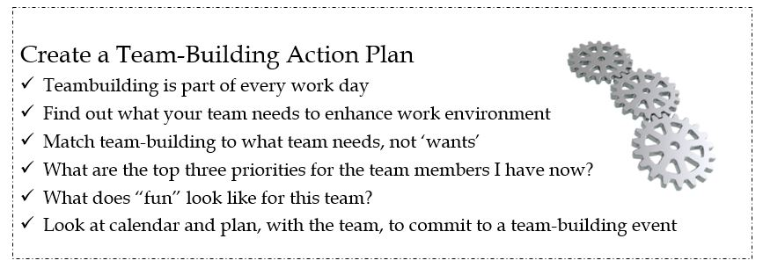

Break Your Team Worksheet
Developed by the Global College of PME
You have an effective team. Now break it. How? Create a checklist to share with the others in your Flight Commander course outlining the skills or behaviors your small group will use to destroy a team and make it the most ineffective team ever.
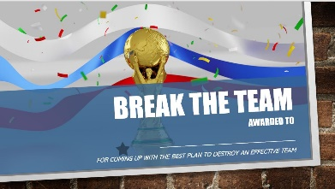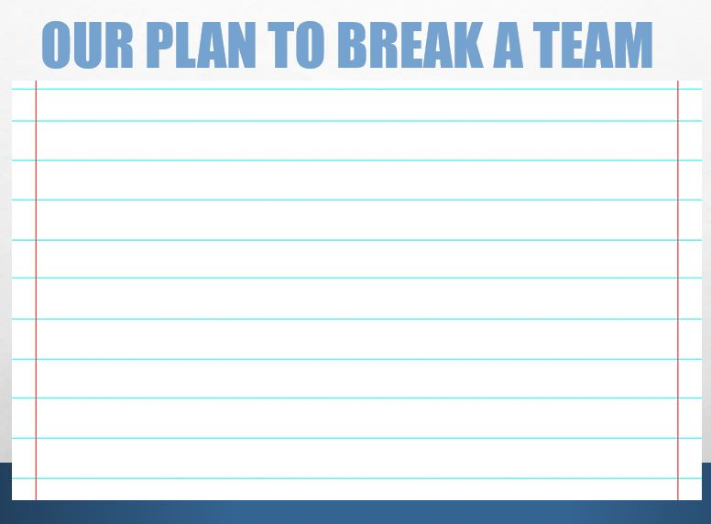

Break Your Team Worksheet (cont.)
Developed by the Global College of PME
Additional notes:
How do you recognize and prevent the behaviors that will break an effective team? How do you fix a team once broken?
Most flight commanders are the new member to a team. Sustaining and maintaining an effective team might be more of a priority than breaking the inherited flight. Your team is who your team is -- make it work!
Behavior/Procedure | Team-Build | Team-Bust | Notes
Emphasize interest & values | agree on team objectives and strategies | disagree on team objectives, strategies, and no cooperation
Ceremonies & Rituals | Conduct initiations, recognition, retirements, special events, etc. | No ceremonies, no recognition
Use Symbols for Group Identity | use logos, slogans, team names, flags, banners, etc. | no use of symbols or group identity methods
Encourage and Facilitate Social Interaction | social committees, planned dinners, luncheons, outings, activities, break room | no social activities, no activity or break rooms
Group Activities and Achievements | keep team informed, explain team performance on the mission | keep team alienated, uninformed regarding their performance
Conduct Process Analysis | solicit team feedback on process improvements, suggestions, | no solicitation of team feedback or process input
Conduct Alignment Sessions | solicit input for team values, concerns, objectives, provide mutual understanding | no solicitation from team, no promotion of mutual understanding of values or concerns
Increase Incentives for Mutual Cooperation | provide informal awards, bonuses, time off, celebrations for performance | no awards, incentives, programs that provide incentives for performance

Self-Assessment Worksheet
This self-assessment provides an opportunity for you to assess your own leadership skills and behaviors. These skills and behaviors are based upon the concepts addressed within this lesson. You will use these worksheets again during the final lesson of the course.
NOTE: Not all these skills and behaviors were covered in this lesson, rather, they reflect what an ideal flight commander should know and be able to do in this topic area.
Rate yourself on a scale of 1-5 in each of the areas below:
5 – Needs No Improvement 3 – Average 1 – Needs Significant Improvement
ICL Reference  People/Team | Skill | Behavior | Self-Assessment  (1-5)
Fostering Collaborative Relationships | Builds Effective Teams | At the team or flight level:  - Inspire Commitment  - Communicate vision  - Empower individuals  - Engender trust  - Accomplish mission  - Uses technology to support team  - ________________
Fostering Collaborative Relationships | Sustain Effective Teams | At the team or flight level:  - Provide resources for training  - Present challenging assignments  - Sustain relationships among team  - Improve relationships among team  - Give feedback on team processes  - Establishes remote team ROEs  - ___________________________
Leading People | Takes Care of People | At the team or flight level:  - Encourage fairness / inclusiveness (integrate new members)  - Promote mutual trust  - Apply accurate evaluation  - Obey laws and regulations  - Promote high standards  - Take responsibility  - Provide resources for remote tasks  - ________________________
(See tips on reverse)

Some tips:
- Ask your supervisors, peers, and subordinates how they perceive your behaviors in these areas. Often, we are biased toward ourselves, meaning we tend to rate ourselves better than others actually perceive us. In leadership we must strive to minimize the differential between how we think we behave and how others perceive our behaviors.
My Notes

